**First we will create table employee:**



**Now we will load our data from local path to the table employee using load command:**

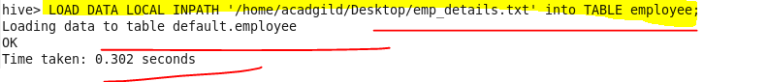

**Now using select command we can show data of the table:**

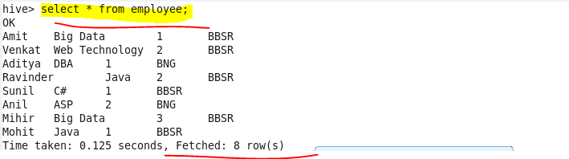

**Solution:**

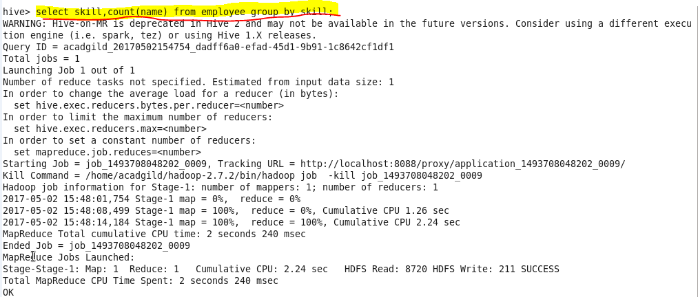

**Output :**

